实验三

数组：

一、#include <iostream>

using namespace std;

int main()

{int arr[10];

cout << "请输入十个数字" << endl;;

for (int n = 0; n < 10; n++)

{

cin >> arr[n];

}

int size = sizeof(arr) / sizeof(arr[0]);

int vis[10] = { 0 };

for (int i = 0; i < size; i++)

{

if (vis[i] == 1)

{

continue;

}

else

{

for (int j = i + 1; j < size; j++)

{

if (arr[i] == arr[j])

{

vis[j] = 1;

}

}

if (vis[i] == 0)

{

cout << arr[i] << " ";

}

}

}

return 0;

}

运行结果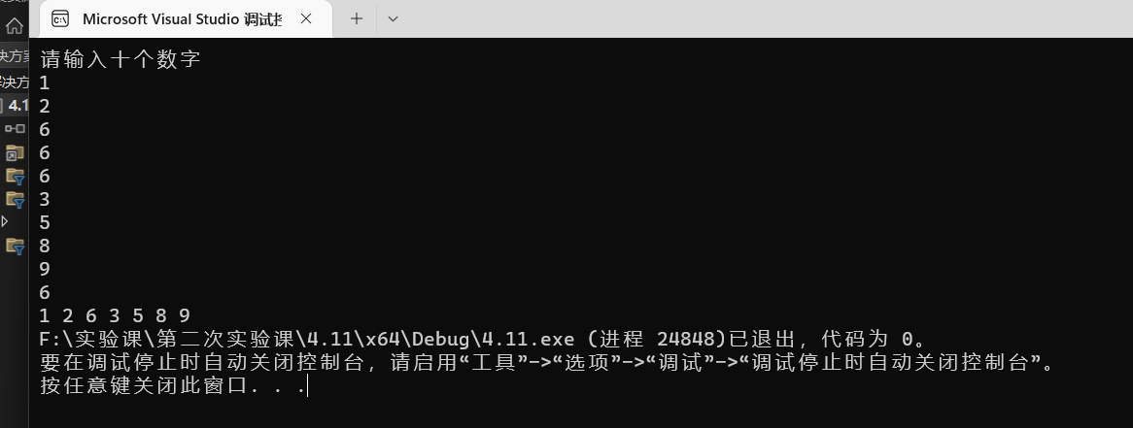

二、

#include<iostream>

using namespace std;

int main()

{

int a[10];

int i, j;

for (int n = 0; n < 10; n++)

{

cin >> a[n];

}

for (int j= 0; j < 9; j++)

{

for (int i = j+1; i <10; i++)

{

if (a[j]> a[i])

{

int t = a[i ];

a[i] = a[j];

a[j] = t;

}

}

}

cout << "排列后为：";

for (int i = 0; i < 10; i++)

{

cout << a[i] << ",";

}

return 0;}

运行结果：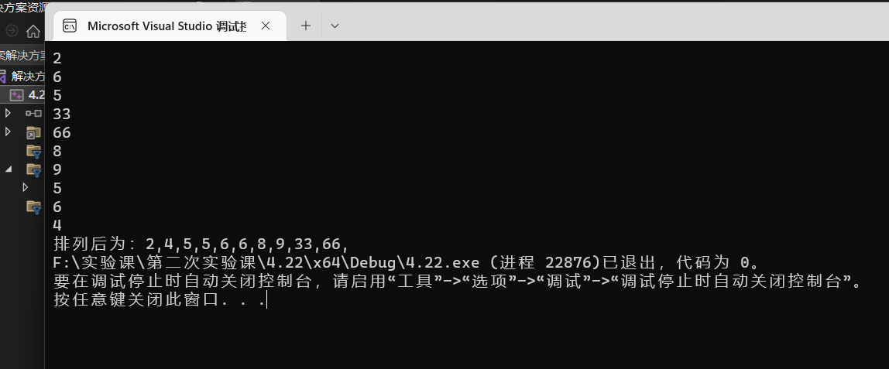

三、#include<iostream>

using namespace std;

int main()

{

int* p ;

p=new int [100];

int n;

for (n =0; n < 100; n++)

{

*(p+n)=1;

}

for (int j = 2; j <= 100; j++)

{

for (int i = j; i <= 100; i = i + j+1)

{

*(p + i)== 0 ?( * (p + i) = 1) :(*(p + i) = 0);

}

}

for (n = 0; n < 100; n++)

{

if(*(p + n) ==1)

{

cout << n+1<<",";

}

}

return 0;

}

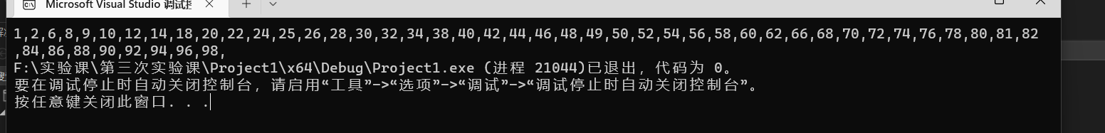

四、#include<iostream>

using namespace std;

int main()

{

int p, b;

int* m, * n;

cout << "请输入数组一的元素个数" << endl;

cin >> p;

cout << "请输入排列好的第一个数组" << endl;

m = new int[p];

for (int i = 0; i < p; i++)

{

cin >> *(m+ 0);

}

cout << "请输入数组二的元素个数" << endl;

cin >> b;

cout << "请输入排列好的第二个数组" << endl;

n = new int[b];

for (int i = 0; i < b; i++)

{

cin >> *(n+ 0);

}

int s = p + b;

int* h;

h = new int[s];

for (int i = 0; i < p; i++)

{

*(h + i) = *(m + i);

}

for (int i = p; i < s; i++)

{

for (int j = 0; j < b; j++)

{

*(h + i) = *(n + j);

}

}

for (int j = 0; j < s-1; j++)

{

for (int i = j + 1; i < s; i++)

{

if (*(h+j) > *(h+i))

{

int t = *(h+i);

*(h+i) = *(h+j);

*(h+j) = t;

}

}

}

cout << "排列后为：";

for (int i = 0; i < s; i++)

{

cout << *(h+i) << ",";

}

return 0;

}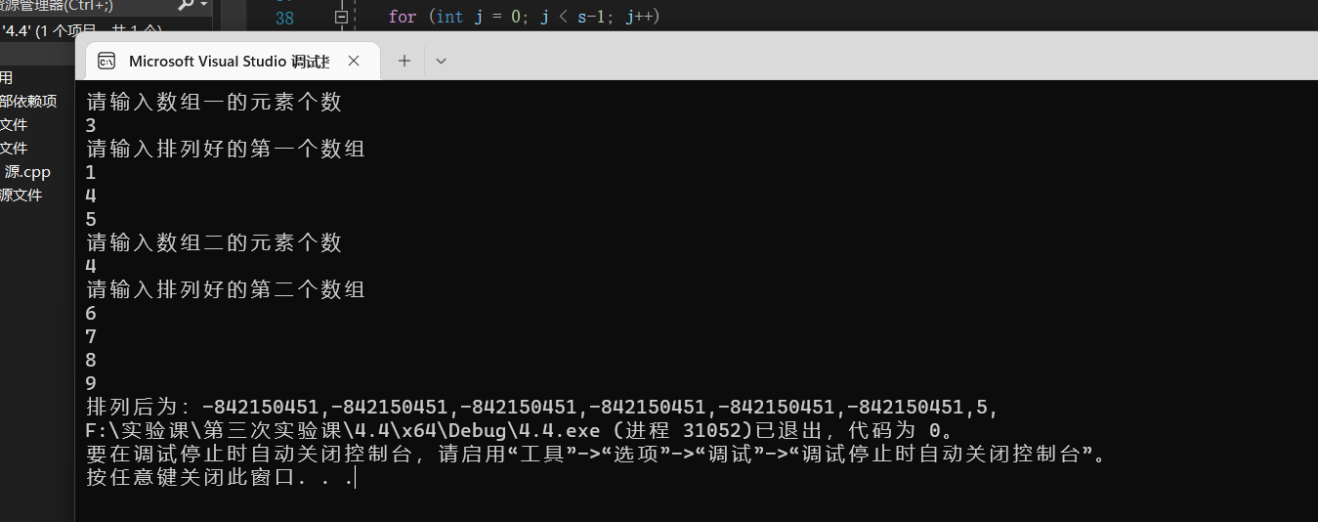

五、

#include<iostream>

#include<string>

using namespace std;

int main()

{

char a[30], b[30];

cout << "请输入第一个字符串" << endl;

cin.getline(a, 30);

cout << "请输入第二个字符串" << endl;

cin.getline(b, 30);

int m = strlen(a);

int n = strlen(b);

int w=0,num=0;

for (int i = 0,int j=0; j<n; i++)

{

if (a[i] != b[j])

{

w++;

if (a[i] == ' ')

{

w--;

}

}

else if (j < n)

{

if (a[i] == b[j])

{

num++;

j++;

}

}

}

if (num == n)

{

cout << w + 1 << endl;

}

else cout << "-1";

return 0;

}

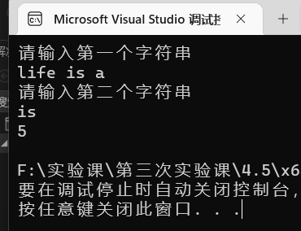

六、#include<iostream>

#include<string>

using namespace std;

int num[26]={0,0,0};//用0到25表示字母a到z

int main()

{

char c;

int m = -1;//用于统计字母是否出现

string date;

cout << "请输入字符串" << endl;

cin >> date;

for (int i = 0; i < date.size(); i++)

{

if (date[i] >= 'a' && date[i] <= 'z')

{

m = date[i] - 'a';

}

else if (date[i] >= 'A' && date[i] <= 'Z')

{

m = date[i] - 'A';

}

if (m != -1)

{

num[m]++;

}

m = -1;

}

for (int j = 0; j < 26; j++)

{

if (num[j] != 0)

{

c = j + 'a';

cout << c << "的数目为" << num[j] << endl;

}

}

return 0;

}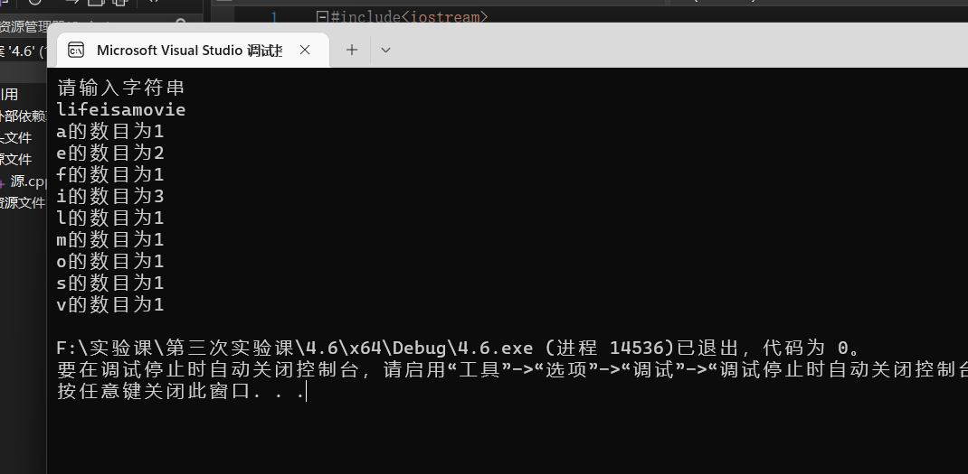

指针：

2.1：

#include<iostream>

using namespace std;

int judge(char a[30], char b[30])

{

int m = strlen(a);

int n = strlen(b);

int w = 0, num = 0;

for (int i = 0, int j = 0; j < n; i++)

{

if (a[i] != b[j])

{

w++;

if (a[i] == ' ')

{

w--;

}

}

else if (j < n)

{

if (a[i] == b[j])

{

num++;

j++;

}

}

}

if (num == n)

{

cout << w + 1 << endl;

}

else cout << "-1";

return 0;

}

int main()

{

char (*a)[30],(* b)[30];

cout << "请输入第一个字符串" << endl;

cin.getline((*a), 30);

cout << "请输入第二个字符串" << endl;

cin.getline((*b), 30);

cout << judge(*a,*b );

return 0;}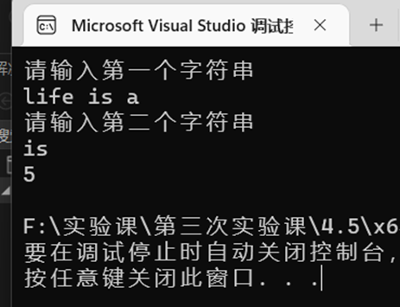

2.2：

#include<iostream>

#include<string>

#include<cmath>

using namespace std;

int parseHex(const char* const hexString);

int main()

{

int size = 999;

char s[999];

cout << "Please enter a number in hexChar : \n";

cin.getline(s, size);

cout << "Tne number " << s << " in hexChar is " << parseHex(s) << " in decimal\n";

return 0;

}

int parseHex(const char* const hexString)

{

int a, sum = 0;

a = strlen(hexString);

int list[a];

for (int i = 0; i < a; i++)

{

if (hexString[i] >= 'A' && hexString[i] <= 'F')

list[i] = (static_cast<int>(hexString[i]) - 55) * (pow(16, a - 1 - i));

else

list[i] = (hexString[i] - 48) * pow(16, a - i - 1);

sum = sum + list[i];

}

return sum;

}  




2.3：

#include<iostream>

using namespace std;

int main()

{

int s, * h;

cout << "请输入数组个数" << endl;

cin >> s;

cout <<"请输入数组元素" << endl;

h = new int[s];

for (int i = 0; i < s; i++)

{

cin >> *(h + i);

}

for (int j = 0; j < s - 1; j++)

{

for (int i = j + 1; i < s; i++)

{

if (*(h + j) > *(h + i))

{

int t = *(h + i);

*(h + i) = *(h + j);

*(h + j) = t;

}

}

}

cout << "排列后为：";

for (int i = 0; i < s; i++)

{

cout << *(h + i) << ",";

}

return 0;

}

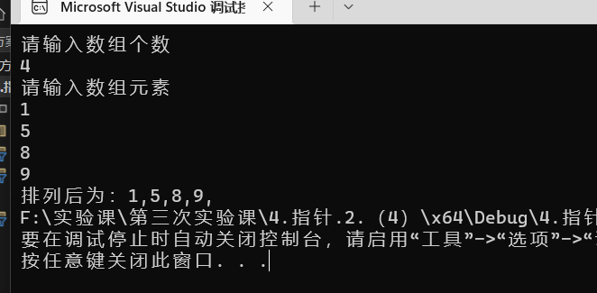

遇到的问题：在写开关柜子游戏的问题时，没有思路。但是经过我在吃饭和出去玩的闲暇时刻的不停思考，终于想到了解决方法。

感悟：多多思考，总能解决一些似乎没有头绪的问题。